**Trading Market Reversals**

Eight reversals that can be effectively trade

* Previous day's high - raid buy stops & reverse

Knowing the conditions that leads to a raid on buy stops of the PDH

* Previous day's low - raid sell stops & reverse
* Intra week high - raid buy stops & reverse

Think of the weekly market profiles, tuesday can create a false high or a false decline

* Intra week low - raid sell stops & reverse
* Intermediate term high - raid buy stops & reverse Last week high or a couple weeks ago

Longer term, again look at the purpose and whats the stoyline behind it? Is it pairing up those others to exit longs, or is going up there to engineer liquidity to put people on the wrong side and take that out to then take off? Not every old high is going to be 1 to go short at. Are going to continue? Or are we going to reverse because above that high is a HTF filled PD array, or are we going above that high after a long uptrend where logical profit taking will be met?

* Intermediate term low - raid sell stops & reverse

Last week low or a couple weeks ago, or previous month.

* New York session reversals

Generally its a continuation of what was established in London, but there are instances that London rallies up and New York reverse and takes out Londons low of the day, that occurs when New York trades up into a HTF premium array. Vice versa for the opposite side ofc.

* London close reversals

Everything from New York reversals applies to this, but also intraday on large range days (A day that has exceeded the 5 day ADR) when it rallies on a large range day we can anticipate a reversal during London close and it could provide an intraday scalp. ICT likes to only do this when ADR has been exceeded by 1.25 or 1.3%. He doesnt like it when it was a small range day or when it didnt really explode to 1 side

London open judas New York open judas Asia judas

London close judas on particular days

Its all the same stuff, by itself theyre pretty useless but if they trade into a PD array it becomes very high probability

How to know if the low/high will get swept and it just wont run further?

By itself it doesnt work, there has to be other things that blend well, there has to be more context When were looking for a market reversals

1. a clear indication it wants to go the opposite direction

Trading previous days highs and lows

[gl Trading Intra-Week Highs

[gl Trading Intra-Week Lows

[gl Trading intermediate term high & low reversals

[gl New York session reversal

[gl London Close reversals

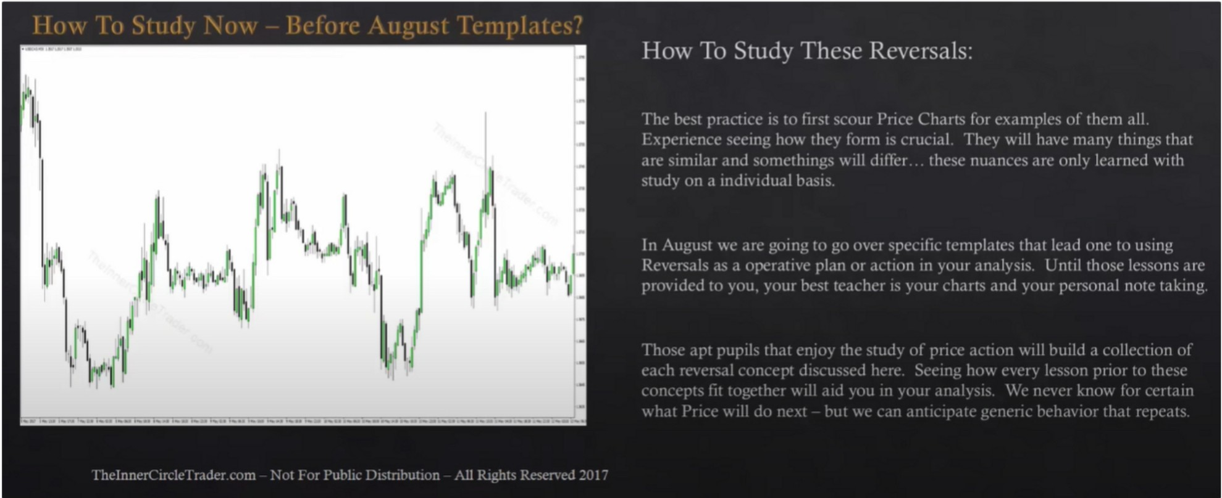

2nd time watching:

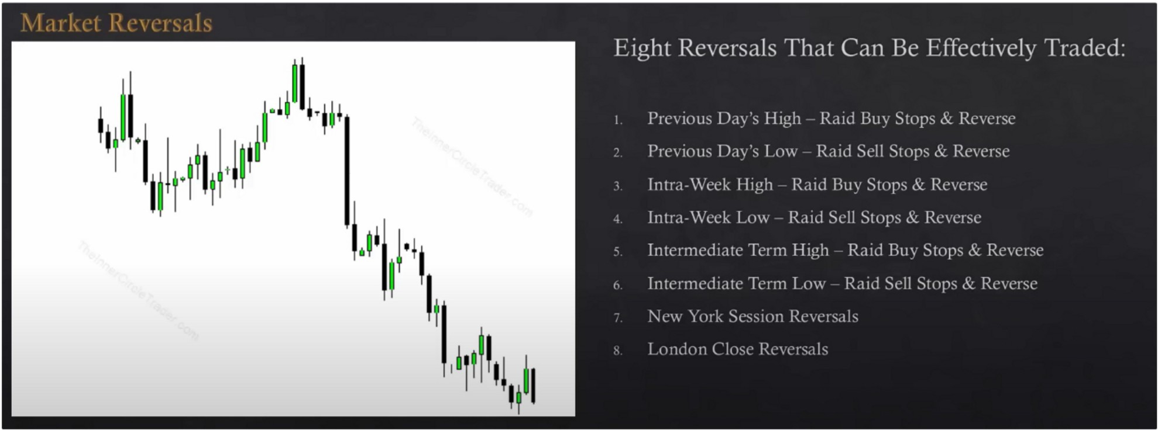

Eight reversals that can be effectively trade

* Previous day's high - raid buy stops & reverse

Knowing the conditions that leads to a raid on buy stops of the PDH is one of the gems of this teaching

Theres criteria ICT looks for, not every PDH is going to have the same effect

* Previous day's low - raid sell stops & reverse

By itself we dont just by old lows and sell above old highs, theres other stuff you need to incoorporate

* Intra week high - raid buy stops & reverse

Think of the weekly market profiles, tuesday can create a false high or a false decline if it hasnt yet traded to the premium array

If weve been trading up and we have not yet come into a premium array, we can look for price

to take out an intra week high into a premium array

* Intra week low - raid sell stops & reverse

We see the lowest low of the week et swept and it reverses, for daytrading and scalping these are really high probability trades, even if it doesnt continue higher you can still get a tradeable bounce. Whatever the low of the week is and that coupled with a discount array below thats high probability. For example if tuesday traded lower then higher and wednesday dropped again and takes out tuesdays low and hits that discount array thats a wonderful opportunity

* Intermediate term high - raid buy stops & reverse Last week high or a couple weeks ago

Longer term, again look at the purpose and whats the stoyline behind it? Is it pairing up those others to exit longs, or is going up there to engineer liquidity to put people on the wrong side and take that out to then take off? Not every old high is going to be **1** to go short at. Are we going to continue? Or are we going to reverse because above that high is a HTF PD array, or are we going above that high after a long uptrend where logical profit taking will be met?

* Intermediate term low - raid sell stops & reverse

Last week low or a couple weeks ago, or previous month.

Like we said with the highs, there has to be a context behind it. Are they profit taking or will this be the start of a longer rally to go higher?

* New York session reversals

Generally its a continuation of what was established in London, but there are instances that London rallies up and New York reverses and takes out Londons low of the day, that occurs when New York trades up into a **HTF** premium array. Vice versa for the opposite side ofc.

* London close reversals

Everything from New York reversals applies to this, but also intraday on large range days (A day that has exceeded the 5 day ADR) when it rallies on a large range day we can anticipate a reversal during London close and it could provide an intraday scalp. ICT likes to only do this when ADR has been exceeded by 1.25 or 1.3%. He doesnt like it when it was a small range day or when it didnt really explode to **1** side

Go in the charts, thats the best way to learn, you only need to know the concept you dont need 50 different examples.

Arjo I Twitter, lnstagram I Linktree

Linktree. Make your link do more.

, https://t.co/HhmmTN1fUI

JavaScript is not available.

***"!JI*** https://twitter.com/arjoio